

**Table of Contents**

EXECUTIVE SUMMARY 3

ROLES AND RESPONSIBILITIES 3

COMPANY OVERVIEW 4

COMPETITIVE ANALYSIS: Bank of Nova Scotia vs. RBC Bank 5

PESTEL ANALYSIS 5

SWOT ANALYSIS 6

PROBLEMS TO BE SOLVED 6

REQUIREMENTS 8

AS -IS DIAGRAM (UPI IN INDIA) 14

AS-IS DIAGRAM(INTERAC PROCESS) 15

TO-BE DIAGRAM (PROPOSED UPI SYTEM FOR SCOTIA BANK) 16

PROCESS FLOW EXPLANATION 17

Adding Recipient 20

POSSIBLE SOLUTION OPTIONS 21

EVALUATION CRITERIA 21

Evaluation of Solution 1 - Adding the UPI Option in the Existing Scotia Bank Mobile App 21

Evaluation of Solution 2 - Launching an Independent UPI Application 21

Evaluation Criteria Table 22

SOLUTION RECOMMENDATION 22

ROI CALCULATION 23

SOLUTION 1 PROTOTYPE 26

DATABASE DESIGN 34

DATA ELEMENTS & DEFINITION 34

SCOTIABANK DATABASE AFTER NORMALIZATION 42

RISK LOG 42

IMPLEMENTATION STRATEGY 43

TESTING STRATEGY 44

Solution #1 - (ADDING THE UPI OPTION IN THE EXISTING SCOTIA BANK MOBILE APP) 44

REFERENCES 47

# EXECUTIVE SUMMARY

Incredibles Inc. has successfully undertaken a pivotal project for Scotia Bank, focusing on integrating the Unified Payments Interface (UPI) system. This initiative is part of Scotia Bank's strategic move to stay at the forefront of financial technology innovation and provide enhanced digital payment solutions to its customers.

The project aimed at seamlessly integrating the UPI payment system into Scotia Bank's existing infrastructure, ensuring secure, efficient, and user-friendly payment conditions. The UPI system is designed for interoperability with various banking systems and payment apps, fortified with robust authentication, encryption, and fraud detection mechanisms.

The Scrum agile framework was the chosen methodology, aligning with the project's complexity and need for iterative development. The project was planned over three months, divided into one-week sprints involving developing the product backlog, goal setting, and staffing. The multifunctional Scrum team focused on designing, testing, and refining the UPI system, adhering to the Definition of Done, and conducting retrospective meetings for consistent progress and improvement.

This report will encompass a comprehensive analysis and documentation, including Assessing Scotia Bank's market position relative to competitors in digital payment technologies. A detailed overview of project requirements and specifications. Visual representation of current and future state processes post UPI integration. Metrics and benchmarks for evaluating project success. Financial analysis highlighting the project's profitability and cost-effectiveness. Outline of the database architecture supporting the UPI system. Documentation of potential risks identified and mitigated throughout the project. Detailed strategy for the deployment of the UPI system. Framework and approach for testing the UPI system to ensure functionality and security.

# ROLES AND RESPONSIBILITIES

|  |  |
| --- | --- |
| NAME | ROLE |
| Abimbola Sanni | Project Manager |
| Bhupinder Singh | Assistant Project Manager |
| Geethu Joy | Team Member, Business Analyst |
| Maheep Kaur | Team Member, Business Analyst |
| Yash Surti | Team Member, Business Analyst |

# COMPANY OVERVIEW

Scotiabank is a leading bank in the Americas. Guided by its purpose: "for every future," we help our customers, their families, and their communities achieve success through a broad range of advice, products, and services, including personal and commercial banking, wealth management and private banking, corporate and investment banking, and capital markets.

The Bank offers a wide variety of products and services, including wealth management, commercial, corporate and investment banking. Serving more than a 25million customers around the world with over 97,000 employees and over 1200 branches worldwide, it is currently the 3rd Largest Bank by deposits and market capitalization in Canada. Earning about $ 2.16 billion ($1.69 per share) for Q2 2023, it currently trades on the Toronto Stock Exchange (TSX: BNS) and New York Stock Exchange (NYSE: BNS). Founded in Halifax, Novia Scotia, in 1832, and the headquarters (Scotia Plaza) is in Toronto. The Bank has about 14 Directors on its Board. The 33-member executive management is led by President and CEO Scott Thomson.

With 4 key values: Respect, Integrity, passion and accountability, Scotia Bank is committed to net-zero operations by 2030. It has a solid global Diversity, Equity, and Inclusion strategy. It aims to increase the representation of people of colour in senior leadership roles by 30% or greater. It also wants to increase its workforce representation of women, visible minorities, indigenous people, the LGBT+ community and persons with Disabilities.



(www.scotiabank.com)

Scotia Bank plans to introduce a new digital payments platform, "Scotia TranXact," to support business clients' digital transformation. This platform allows businesses to embed digital payment services into their workflows, enabling real-time, frictionless experiences for customers. (Innovation Spotlight: New Digital Payments Platform Scotia TranXact Supports Business Clients' Digital Transformation, 2022).

# COMPETITIVE ANALYSIS: Bank of Nova Scotia vs. RBC Bank

**Account Maintenance Fees:**

* Scotiabank's Basic Banking Plan: The preferred package costs $15.95 a month, while the general one costs $3.95.
* RBC's No Limit Banking account: No limit bank account with a signature-no: $30 per month; $10.95 per month. (Staff, 2023)

**Debit Transaction Fees:**

* The charge per debit transaction is $5 by Scotia Bank.
* RBC’s transaction fees are also tied to their service packages. For example, the Day–to–Day Banking account provides 12 free debit withdrawals every month but charges one dollar for each additional transaction. Signature No Limit Banking account allows free debit transactions without charges limit from RBC. (Staff, 2023)

**Savings Account:**

* No fees are charged in saving accounts at Scotiabank, which have an interest rate of 0.05%.
* On the other hand, RBC charges a low rate of 0.01% while deducting a $4 monthly maintenance fee. (Staff, 2023)

**Reputation and Market Presence:**

* As far as local and international standing is concerned, Scotiabank is one of the leading banks with a robust and reputable image. (Scotiabank (BNS) - Market Capitalization, n.d.)

## PESTEL ANALYSIS

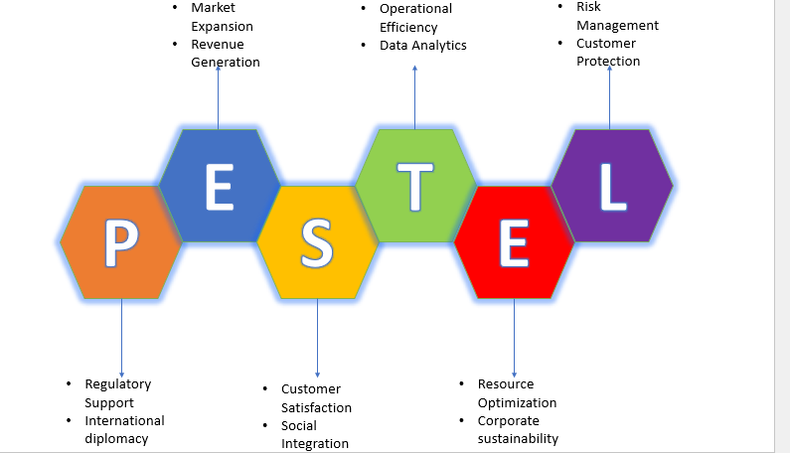

## SWOT ANALYSIS

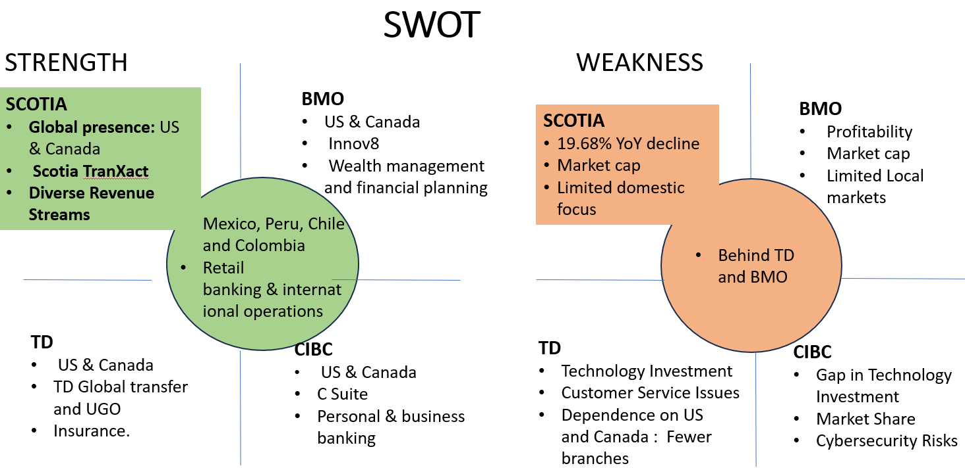

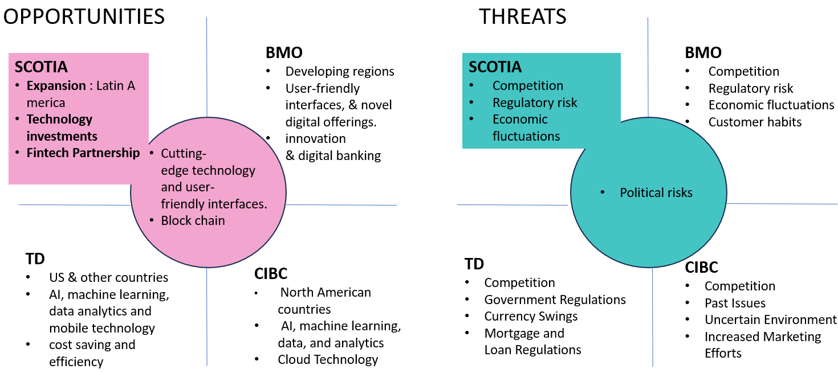

# PROBLEMS TO BE SOLVED

Scotia Bank's move towards payment technology to adopt the Unified Payments Interface (UPI) is a step ahead. One practical solution is integrating UPI, which provides an appropriate payment option for customers’ evolving demands. It enhances Scotiabank’s advantage by offering time and interoperable solutions that appeal to technology-loving clients interested in transaction fastness. UPI also supports cross-border transactions and makes payments more secure, thus boosting Scotiabank as a bank with cutting-edge technology (Jacob, 2021).

However, before implementing UPI, there should be an analysis of costs/benefits, market demand, risks, legal issues, etc. Further, UPI portrays a transition towards digital banking tailored to serving customers’ needs. Scotiabank is an intelligent, results-oriented industrial manager who puts customer satisfaction first through accepting payments, productivity, and conformity to the business environment. (Jacob, 2021).

The thorough answer highlights Scotiabank's deliberate implementation of the Unified Payments Interface (UPI) payment system, showcasing the bank as progressive and committed to maintaining its lead in the ever-changing financial industry. The language emphasizes the bank's proactive responsiveness to changing consumer preferences and new technology to keep a competitive advantage and satisfy customer expectations. (Unified Payments Interface, 2023)

The complete list of advantages of Scotiabank's UPI deployment is provided, emphasizing how a secure payment environment will improve the client experience. UPI is promoted to boost client retention, loyalty, and satisfaction. The statement also highlights Scotiabank's competitive edge, demonstrating its commitment to cost-effectiveness and innovation compared to conventional payment options. The total effect is described as a complex strategic choice affecting financial industry practitioners and academics. (Unified Payments Interface, 2023)

**Project selected**

|  |
| --- |
| **Project Title**: Scotia UPI System |
| **Project Start Date:** September 12, 2023 **Projected Finish Date:** December 14, 2023 |
| **Budget Information: 5.4 billion Dollars** |
| **Project Manager:** Abimbola Sanni, 513 (226) 5678, asanni5932@conestogac.on.ca |
| **Project Objectives:**   * Integrated the UPI payment mechanism into Scotiabank's infrastructure successfully. * Our clients enjoy prompt, secure, and unbreakable payment terms. * Use innovation to get a competitive edge in the financial sector. * To increase production while lowering operational expenses with improved interest. |
| **Success Criteria:**  The UPI project's primary objectives are to enhance user experience, guarantee transaction reliability, save operating costs, increase Scotiabank's market share, and finish the project on schedule and under budget. |
| **Approach**   * We will start extensive planning, including risk communication methods and assembling a varied project team. * We will collaborate extensively with all involved parties to fully comprehend their needs, as this will direct UPI's design, development, and meticulous testing. * Train staff, notify clients, and roll out the system gradually when approval has been obtained and signed off. * Monitor performance continuously and make necessary adjustments based on input until the project is completed. |

# REQUIREMENTS

|  |  |
| --- | --- |
| **ID** | **FUNCTIONAL REQUIREMENTS** |
| FR-01 | **Enrolments of Users in UPI Services** By verifying their identity and linking their bank account and cell phone number, users may effortlessly sign up for UPI services. Through this procedure, consumers may ensure authorized transactions by creating a UPI ID and setting up their accounts for transactions. |
| FR-02 | **Initiation of UPI Transactions** Users should be able to initiate transactions by entering the receiver's UPI ID, selecting the bank account that goes with it, and entering the desired transfer amount into the system. With the use of this service, users may transmit money via UPI. |
| FR-03 | **Two-Factor Authentication** The system will use two-factor authentication to improve the security of transactions and deny access to them. A one-time password (OTP) is sent to the user’s registered number for transaction authorization. This provides an extra barrier against malicious attacks while simultaneously authenticating and securing all transactions. |
| FR-04 | **Transaction History Accessibility** Users must be able to retrieve their transaction history on demand with information such as amount, UPI ID of sender/recipient and transfer date. It enables the user to check for transactions and review them accordingly. |
| FR-05 | **Receipt Generation** The system generates a receipt with transaction details, which will be sent to the user on the registered email after a successful transaction. Moreover, their transactions ought to be recorded so that they can refer to any disputes. |
| FR-06 | **Adding Multiple Bank Accounts** As well as that, using the UPI ID users have many choices regarding transaction fees. The user can link several bank accounts to each UPI ID. This enables users to have options in handling their trades. |
| FR-07 | **Real-Time Transaction Processing** UPI’s platform shall be designed to process UPI transactions without noticeable delay in fund transfer between the accounts to ensure UPI's reputation remains intact. |
| FR-08 | **Regular Software Updates** The system will process UPI transactions in real-time to ensure minimal delays before the funds get into accounts, thereby safeguarding UPI as an efficient platform. |
| FR-09 | **Customer Support Integration** This will constitute ongoing enhancements of software upgrades to address present challenges while bolstering the security and functionality of the system. The need is vital for constantly upgrading the efficacy, safety, and aptitude of the UPI for its users. For this reason, the system needs to have an interactive function where users can interact with the design for inquiries or queries. In addition, it will allow users to file questions on the UPI service, obtain reports, or make complaints. It enables users to seek assistance to maintain customer satisfaction in providing service that meets their preferences. |
| FR-10 | **UPI Complaint and Dispute Resolution** There must be an avenue through which UPI transaction users can register their grievances and objections. The resolutions of these complaints should be carried over this period. This strategy guarantees timely resolution of end-user complaints, which builds confidence and credibility in UPI services. |

|  |  |
| --- | --- |
| **ID** | **SECURITY REQUIREMENTS** |
| SR-01 | **End-to-End Encryption** Encrypting the transaction information sent from customer to bank will be integrated into the UPI system to prevent unauthorized access to this information. Protecting personally identifiable information currently of cybercrime. |
| SR-02 | **Data Privacy and Compliance** The system must satisfy data protection rules, including the GDPR and others about data privacy at a local level. It will ensure that user data is processed, retained, and shared by standard and only in purpose. |
| SR-03 | **Multi-Factor Authentication** During creation, device registration, transaction initiation, and changes in account settings, users of UPI will go through an enhanced factor-authentication process. Such may include one-time passwords, biometrics, and security questions. These authentication mechanisms check transactions and account changes, providing security. |
| SR-04 | **Anti-Phishing Mechanisms** This is to develop anti-phishing mechanisms to prevent phishing attacks during the authentication process of communication channels. This program will educate users on how to tell apart communications by Scotia Bank so that they are not caught up in scamming activities. |
| SR-05 | **Real-Time PRaud Detection** A real-time PRaud detection unit integrates into the UPI to analyze transactions and detect any patterns or fraudulent activities. Upon detection, the system will. Block the transaction. Notify both the users and Scotiabank’s cybersecurity team immediately. |
| SR-06 | **User Privacy Controls** Privacy needs to be implemented whereby users enjoy control over the sharing of transaction information. It provides users liberty over their data and an ability to assert their privacy rights meaningfully. |
| SR-07 | **Regular Security Audits** Scotiabank should undertake periodic security audits and vulnerability analyses as part of a continuous monitoring process to identify and address risks associated with the UPIP. This maintains the reliability and safety of the system. |
| SR-08 | **User Data Minimization** Data minimization is practiced in collecting UPI system data for transaction processing and regulatory compliance. This mitigates the risks of a data breach while strengthening privacy protection. |
| SR-09 | **Incident Response Plan** An all-inclusive incident response plan needs to be created, which will entail steps involved in identifying, managing, and thwarting security incidents. The program should also state the communication strategies for informing the affected users and regulatory bodies in case a security breach occurs. |
| SR-10 | **Secure APIs** UPI integration involves using APIs, which need developing practices and regular tests to guarantee safety from vulnerability. This prevents leakages, as well as unauthorized access to data. |
| SR-11 | **Employee Access Management** After the principle of privilege (PoLP), strict access management policies should be enforced to allow only authenticated Scotiabank personnel to gain access to the users’ information. It reduces internal security risks and prevents misutilization of user data. |

|  |  |
| --- | --- |
| **ID** | **PERFORMANCE REQUIREMENTS** |
| PR-01 | **Transaction Speed** UPI takes at most ten seconds to process a transaction. The system must be able to maintain its transaction speed permanently during operational times to ensure continuous services. |
| PR-02 | **System Availability** Scotiabank UPI service should be available at least 99.95% of the time to ensure that users can access and use the system besides scheduled maintenance and unpredictable occurrences. This shows how reliable and easy it is to use the system. |
| PR-03 | **Scalability** As the number of users increases and transactions per second increases, the UPI platform must cope with this increasing load without affecting performance. |
| PR-04 | **Concurrent Users Handling** The system must support [number] users without affecting transaction speed, security, and other performance parameters, considering that the bank customers are varied. |
| PR-05 | **Data Throughput** UPI system should provide continuous transaction consistency by providing a high data rate in the communication link between user interfaces, bank servers and interbank systems without time lag. |
| PR-06 | **Failover Capabilities** The UPI system automatically switches to a second mode as a backup in case of a system failure or during disruptive occurrences to ensure that services are always available and help curb transaction disruptions. |
| PR-07 | **Response Time** It needs to give customers information about their transactions like payment, account balance and history of transactions. It will also ensure the user interface responds to a better user experience. |
| PR-08 | **Data Backup** The information is crucial as it prevents data loss and enables data recovery from system failures and corrupt data. The backup of this data must be secured on a server. |
| PR-09 | **Load Balancing** It is imperative to have solid load-balancing capabilities to maintain the system's performance. This spreads load transactions among servers, avoiding server overloading during peak transactions. |
| PR-10 | **Latency** Minimizing latency in the data transmission between user devices, UPI platform and bank servers for the transaction processing and retrieval process. Therefore, it should be noted that a system's latency must be as minimal as possible. |
| PR-11 | **Resource Utilization** The system must be monitored and optimized based on usage parameters like CPU, memory, and network resources. It helps avoid putting unnecessary strain on resources. Performance degradation can be prevented. |
| PR-12 | **User Session Management** Logging in, secure transaction processing and timely session timeout depend on successfully handling user sessions. This prevents access and safeguards it from any other form of threat. |

|  |  |
| --- | --- |
| **ID** | **AVAILABILITY REQUIREMENTS** |
| AR-01 | **Service Uptime** Backup and failover systems for the components should be implemented to avert service interruptions. In this way, the operation of the service will go on regardless of hardware failures or otherwise. |
| AR-02 | **Redundancy Mechanisms** Users shall receive notice of planned maintenance activities via scheduled maintenance windows. If possible, such activities should occur when there is usage so as not to disturb users’ experience. |
| AR-03 | **Maintenance Windows** Developing a well-thought-out incident management program to address problems related to the availability of services will be done. The plan involves methods for communication, identification, escalation, and resolution of incidents. |
| AR-04 | **Incident Response** The load balancing will implement a distributed system across servers to distribute users’ requests and avoid congestion. By so doing, each server will be manageable—impacts on the accessibility and efficiency of the service. |
| AR-05 | **Load Balancing** The load-balancing strategy that is used should be effective in distributing users’ requests across servers. Every server this way is made manageable. This leads to low availability, poor quality, and unreliable service. |
| AR-06 | **Disaster Recovery** This will imply developing a disaster recovery plan. These ensure that UPI services can be restored in cases of failure or disaster. It will establish recovery time objectives (RTO) for the system’s critical services. |
| AR-07 | **Continuous Monitoring** Monitoring mechanisms need to run continuously to detect any problems with system performance and availability. By adopting this approach, issues get resolved promptly to minimize downtimes. |
| AR-08 | **Data Backup and Restore** To be available in case of data loss, make your data backups, and the data restoration mechanism should work well. This approach will ensure that transaction histories and user data are retrieved without affecting the system’s availability. |

|  |  |
| --- | --- |
| **ID** | **TECHNICAL REQUIREMENTS** |
| TR-01 | **Platform compatibility** Ensuring compatibility across platforms is essential for UPI services. The app should be designed and developed to work smoothly on devices and operating systems like Android phones, iPhones, Windows PCs, and tablets. This broad compatibility allows ecosystem users to access UPI services without any difficulties. |
| TR-02 | **Database integration** To store user and transaction data securely and in a manner that the system needs to integrate with a database, |
| TR-03 | **API integration** Seamless API integration with bank servers, payment gateways and third-party services is a requirement for the UPI platform. |
| TR-04 | **Cloud Infrastructure** Hosting UPI systems on cloud infrastructure is vital to ensure availability, scalability, and security. |
| TR-05 | **Multi-language support** To cater to a user base effectively, the system should support languages. |
| TR-06 | **Notification service** Integrating OTP for security measures and providing users with notification services for transaction alerts and system updates is an aspect of the platform. |
| TR-07 | **Security Protocols** Implementing security protocols such as SSL/TLS for data in transit and AES for data at rest is necessary to safeguard information. |
| TR-08 | **Mobile application development** Developing an app for UPI services that offers a user-friendly interface and seamless experience is crucial. |

|  |  |
| --- | --- |
| **ID** | **LEGAL REQUIREMENTS** |
| LR-01 | **Data protection law** Adhering to data protection laws, such as the General Data Protection Regulation (GDPR) and other local regulations, is essential. |
| LR-02 | **Financial regulations** It is critical to comply with regulations and adhere to the standards set by international banking regulators. |
| LR-03 | **Consumer protection** We must ensure that mechanisms are in place to safeguard consumer's rights when utilizing UPI services. |
| LR-04 | **Digital transaction law** Complying with laws and regulations about transactions and online banking services is crucial. |
| LR-05 | **Intellectual Property** We must ensure that no software or technology infringes upon patents, copyrights, or trademarks. |
| LR-06 | **Licenses and certifications** Obtaining the licenses and certifications in target areas is a requirement for operating UPI services. |

|  |  |
| --- | --- |
| **ID** | **OPTIONAL REQUIREMENTS** |
| OR-01 | **Customize the User Interface:** It allows customers to alter the appearance and arrangement of their UPI dashboard. |
| OR-02 | **Integration with other payment methods** The capability to connect consumers to other payment methods, including debit or credit cards. |
| OR-03 | **Voice command integration** Users can use voice commands to start trade. |
| OR-04 | **International trade** Complies with international banking rules by enabling users to conduct international UPI transactions. |
| OR-05 | **Chatbot support** Use AI-driven chatbots to respond to inquiries quickly. |
| OR-06 | **Advanced analytics** It gives consumers sophisticated analytics tools for monitoring and controlling their spending patterns. |
| OR-07 | **Dark mode** The app has a dark look that is available to lessen eye strain. |
| OR-08 | **Integration with financial planning tools** Users who want to invest and manage their budgets can link their UPI to financial products. |
| OR-09 | **Rewards and loyalty programs** We are establishing a rewards program for consistent users. |
| OR-10 | **Group activities** Enables users to pay for regular costs as a group. |

# AS -IS DIAGRAM (UPI IN INDIA)



# AS-IS DIAGRAM (INTERAC PROCESS)



# TO-BE DIAGRAM (PROPOSED UPI SYTEM FOR SCOTIA BANK)



# PROCESS FLOW EXPLANATION

**To Be Scotia-AS-IS Diagram**

**SENDER**

**DEFINITION: The sender refers to the person, organization or establishment that starts and sends a payment or transfer of funds to another person organization or establishment.**

**Let’s begin the process.**

* **Log in to your Scotia Online banking account.**

**Start by entering your Username and Password to authenticate yourself.**

* **Select the option for making an Interac transfer.**

**Once you're logged in, navigate to the section where you can initiate an Interac transfer.**

* **Check if recipient data is already added.**

**The system will verify whether the recipient’s information has been previously added to your account.**

* **If recipient data is not added.**

**You’ll need to provide the recipient’s details, such as their bank account number, email address or phone number (as required by the system).**

* **If recipient data is already added.**

**Choose the name of the recipient from your list of contacts. Specify the amount of money you wish to transfer.**

* **Check if the recipient data is valid.**

**The system will validate whether the entered recipient information is accurate and complete.**

* **If recipient data is not valid.**

**You'll receive a notification informing you that there's incomplete information regarding the intended recipient. Please make sure to correct these details before proceeding.**

* **If recipient data is valid.**

**Proceed with the step.**

* **Does the recipient have automatic deposit enabled?**

**The system verifies if the recipient has opted for deposits. If they have the funds will be directly deposited into their account without any acceptance required.**

* **If the answer is No.**

**Establish a security question and answer: Since automatic deposit is not enabled for the recipient the sender (user) sets up a security question and answer. The recipient will need to provide the answer to receive the funds.**

* **If the answer is Yes.**

**Deducts the transfer amount from the senders’ account; The system automatically subtracts the specified transfer amount from the sender (users) account. Initiates the process of depositing it into the recipient’s account.**

**Deducts the transfer amount from the senders’ account; The system automatically subtracts the specified transfer amount from the sender (users) account. Initiates the process of depositing it into the recipient’s account.**

**INTERAC System**

**DEFINITION: Interac serves as a payment network across Canada, facilitating transactions between Canadian financial institutions and other businesses. The Interac system offers a range of services, such as debit payments, electronic funds transfers and more.**

* **Scotia Bank sends a request to the Interac system for a transfer.**
* **The process starts when Scotia Bank initiates a transfer request through the Interac system on behalf of its customer.**
* **The Interac system validates the transaction.**
* **Upon receiving the request from Scotia Bank, the Interac system verifies the transaction. This validation process may involve checks, such as confirming account balances, transaction limits and other relevant validations to ensure a transfer.**
* **Informing the recipient’s bank about the transaction.**
* **Once the Interac system has successfully validated the transaction, it notifies the recipient's bank regarding the transfer. This step ensures that the receiving bank is informed and can prepare to credit funds to the recipient's account once all transfer procedures are completed.**

**RECEIPT**

**DEFINITION: The person, often called the recipient, is the organization or establishment meant to receive a payment or value transfer from someone.**

* **The receivers’ bank receives a notification indicating that an e-transfer is waiting to be accepted.**
* **The bank verifies if the recipient’s information matches the details provided in the notification.**
* **If the recipient's information does not match, they are informed about the issue with the transaction due to invalid information.**
* **If the recipient’s information matches, they proceed to log into their banking portal using their Username and Password.**
* **The bank then processes the acceptance of the transfer. Validate the recipient's details to ensure the completion of the transfer.**
* **The bank also checks if an auto deposit is enabled for the recipient’s account.**
* **If the answer is "Yes," The recipient's bank will deposit the transfer amount into the recipient’s account. They don't need to take any steps, as the money will be credited automatically.**
* **If the answer is "No”. The recipient will be asked to provide the security answer that the sender set during the transfer process. This step is necessary because auto-deposit is not enabled.**
* **Is the security answer? The system verifies whether the provided security answer matches what was initially set by the sender.**
* **If the answer is "Yes”. The recipient's bank will credit their account with the transfer amount.**
* **If the answer is "No”. The recipient will be notified that their provided security answer is incorrect. They are required to correct it by re-entering it.**
* **This process concludes either.**

**1. The transfer amount has been successfully credited to the recipient account or**

**2. There are any issues preventing completion of the transfer.**

**SUB PROCESS SCOTIA UPI**

**The diagram provided illustrates a subprocess related to the Unified Payments Interface (UPI) system, specifically focusing on the management and creation of Virtual Private Identities (VPIs). Here's a step-by-step breakdown.**

* **Step 1: Commencement. The process starts when a user engages with the system.**
* **Step 2: Selecting UPI Options from Menu. The user enters the UPI interface and is presented with choices.**
* **Step 3: Checking for Existing VPI. At this point, there is a decision point where the system verifies whether the user already possesses a VPI.**
* **If the answer is YES.**
* **Step 4: Displaying UPI Menu. If the user already has a VPI, they are directed to the UPI menu where they can manage their VPI or utilize other functionalities offered by UPI.**
* **Step 5; Managing VPI. Within the UPI menu, there might be an option that allows users to handle their existing VPIs through actions like editing or deleting them.**
* **Step 6: Additional Options. Option 2 and Option 3 in the diagram serve as placeholders for functionalities or choices within the UPI menu. For example, Option 2 could be "Check balance," while Option 3 might represent "Transaction history." However, since no specific details are provided in the diagram, these options are purely speculative.**
* **Step 7: Scotia UPI Funds Transfer**

**This option suggests a feature for transferring funds to a bank called Scotia. It might enable users to send money to another user using UPI.**

* **Create VPI: If the user doesn't have a VPI, they will be prompted to create one.**
* **The user enters their VPI. Check its availability by clicking on "Check Availability."**
* **The UPI system then responds with the result of the availability check.**
* **If the VPI is already in use, an error message is displayed stating that the VPI is already taken.**
* **If the VPI is available, a message is displayed confirming that the entered VPI is available for use.**
* **The user selects which CASA account number they want to link with their VPI and proceeds with creating it. CASA refers to the Current Account and Savings Account.**
* **Upon creation, a confirmation message is displayed indicating that the VPI has been created.**
* **End: The subprocess concludes, presumably returning the user back to the menu or ending the session.**

**PROPOSED SCOTIA BANK UPI**

User

* Start: The process begins.
* User Selection: The user chooses the UPI options from a provided menu.
* VPA Check: Next, the system verifies whether the user already has a VPA (Virtual Private Address). At this decision point, we ask, "Does the user have a VPA?" represented by the diamond shape.

VPA (Virtual Private Address)

* India VPA Creation: This option allows users to generate a Virtual Private Address for India.
* VPA Management: Users can oversee and control their existing VPA through this option.
* User Input for Transfers: When users wish to initiate a transfer, they need to provide the recipient's VPA along with transfer details.
* VPA Verification: The system verifies the validity of the Payees provided VPA.
* Error Handling.
* If the Payee VPA is found to be invalid (due to entry or nonexistence) the user will be prompted to re-enter the recipient's VPA.
* In case of continued input of a VPA, the system will display an error message notifying the user about their mistake.

UPI System

* The UPI Menu is displayed by the system, presenting the user with a range of options related to UPI.
* To initiate a transfer, the user selects the option from the choices.
* Next, the system brings up a screen specifically designed for UPI transfers. Here, the user needs to provide all the details for the transfer.
* At this stage, the system prompts the user to decide whether they want to transfer funds to a Virtual Private Address (VPA) or directly to a bank account.
* Based on their choice, the user inputs either the recipient's VPA or bank account details along with any required information for the transfer.
* Once all details are entered, it's time for payment review and authorization. The user carefully reviews their payment information before confirming it. Once confirmed, a payment instruction is sent to the UPI system.
* The UPI system processes the transaction. Successfully transfers funds to the recipient. A confirmation message is then displayed to assure the user that their transaction has been completed successfully.
* With that, we reach an end to this transaction process. The user can choose either to exit or proceed with another action if desired.

Payee

* The UPI money transfer screen appears on the system, allowing users to start a money transfer using the UPI platform.
* Next, the user selects the recipient of the transfer. They can choose either a Virtual Payment Address (VPA) or a domestic bank account as the payee.
* Once the payee is selected, the system shows their details. This step ensures that users can verify the recipient’s information before proceeding.
* In this step, users provide transaction details.
* Source VPA: This is the VPA from which funds will be debited.
* Amount: The sum they want to transfer to the payee.

## Adding Recipient

* The process starts by selecting the option to add a contact or recipient to the list. This indicates the user’s intention to save contact information.
* Next, the user is prompted to input details such as the name, email address or phone number of the contact.
* To ensure security and authenticity, a verification code is sent to the user via SMS or call. This step confirms that the user has access to the provided phone number and verifies their authentication.
* Once the user enters the code correctly, they can proceed with adding the recipient to their contact list. However, if an incorrect code is entered, an error message appears. The system then offers an option to resend the code for another verification attempt.
* Finally, after validating and entering the security code, the recipient's information is stored in the user's contact list.
* The process concludes once this step is completed.

# POSSIBLE SOLUTION OPTIONS

This presents three main solution options.

**Solution #1:** Add the UPI option to the existing Scotia Bank mobile app (highlighted). This solution integrates the Unified Payments Interface (UPI) into the existing Scotia Bank mobile app.

**Solution #2:** Launch a separate UPI application. This solution involves creating a new standalone app specifically for UPI transactions.It may offer a dedicated user experience focused on UPI but requires additional development, marketing, and maintenance resources. There are also challenges in integrating with existing banking infrastructure, leading to a fragmented customer experience

**Solution #3 - Do Nothing**: This approach entails maintaining the current banking system without adopting UPI and using Interac as the primary digital payment method. This conservative approach avoids the costs and risks of implementing a new payment system. However, it may result in customer dissatisfaction due to the need for more modern payment options, potential erosion of the customer base, and the risk of falling behind in a competitive market.

# EVALUATION CRITERIA

## Evaluation of Solution 1 - Adding the UPI Option in the Existing Scotia Bank Mobile App

* **Scalability:**Solution 1's modular architecture makes expanding to handle a rising user base and more transactions simple without completely redesigning the system.
* **Profitability:** Incorporating UPI into the Scotia Bank app leverages the current user base to boost transaction volume and fee income, augmenting the service's overall profitability.
* **User Acceptance:**High user acceptability is expected when a user-focused design combines a real-time validation system, a guided interface that goes step-by-step, and a seamless user experience.
* **Cost:** Because Solution 1 builds on the current app architecture, it is less expensive than creating a new platform from the ground up.
* **Accuracy:**Since errors are less likely to occur and user trust is increased, the system's real-time input validation guarantees excellent transaction accuracy.
* **Compatibility:**Solution 1 ensures continuous compatibility with existing systems and procedures by adding features to the present app.
* **Performance and Responsiveness:**The solution focuses on performance optimization, implying that the software will be quick and responsive, resulting in a great user experience.
* **Stakeholder Satisfaction:** A well-executed UPI integration is intended to match the demands of diverse stakeholders, ranging from customers seeking convenience to shareholders seeking financial rewards, resulting in high stakeholder satisfaction.

## Evaluation of Solution 2 - Launching an Independent UPI Application

* **Scalability:** Starting from the ground up, the app's infrastructure may face initial scalability challenges as user adoption grows.
* **Profitability:** Despite the potential for long-term income growth, high upfront research and marketing costs may delay profitability.
* **User Acceptance:** The app's user experience and distinctive features that set it apart from rivals will be critical factors in determining its popularity with users.
* **Cost:**  A standalone app requires a significant financial commitment because of the costs associated with development, infrastructure, and user acquisition.
* **Accuracy:** The app may have more issues initially because it is a new product, which could compromise transaction accuracy until it is fixed through updates.
* **Compatibility:** It will take a lot of resources to make sure the app functions on different devices and operating systems.
* **Performance and Responsiveness:** While maintaining good performance as the programme grows may be complex, optimizing for it from the start is essential.
* **Stakeholder Satisfaction:** Although the software has the potential to generate significant returns over the long term, stakeholders may be wary due to the associated risks and expenses.

## Evaluation Criteria Table

|  |  |  |  |
| --- | --- | --- | --- |
| **SOLUTION CRITERIA** | **SOLUTION 1** | **SOLUTION 2** | **SOLUTION 3** |
| Scalability | 8 | 6 | 0 |
| Profitability | 7 | 5 | 0 |
| User Acceptance | 9 | 6 | 0 |
| Cost | 7 | 4 | 0 |
| Accuracy | 9 | 6 | 0 |
| Compatibility | 8 | 5 | 0 |
| Performance and Responsiveness | 8 | 7 | 0 |
| Stakeholder Satisfaction | 7 | 5 | 0 |
| **TOTAL** | **63** | **44** | **0** |

# SOLUTION RECOMMENDATION

The primary solution recommended is the integration of the Unified Payments Interface (UPI) into an application designed specifically for Scotia Bank. This recommendation is grounded in several key aspects:

**User-Focused Design:** The system is developed with the end user in mind, offering a step-by-step guide from selecting a recipient, entering transaction details, to confirming the payment. This minimizes user errors and enhances the overall experience.

**Modular Architecture:** The solution employs distinct modules for UI, UPI Transaction Handling, Error Handling, and Backend Integration. This modular design facilitates easy maintenance, scalability, and troubleshooting. It also supports the development, testing, and deployment processes

**Effective Interactions:** The system meticulously defines interactions with users' APIs (Application Programming Interfaces) and the bank’s backend systems, ensuring efficient data flow and minimizing bottlenecks.

**Reliable Data Flow Management:** The design separates user transaction and error data flow, ensuring data integrity and security during processing. It aids in audit trails and troubleshooting.

**External Connections:** The design guarantees interoperability with entities like UPI service providers, the bank's backend, and other banks, ensuring seamless transactions and minimizing user difficulties

**Scalability and Performance:** The solution is built with scalability and performance optimization in mind from the start, ensuring long-term effectiveness and user satisfaction.

**Screens and Layouts:** The three-screen approach simplifies the user journey, reducing user load and enhancing clarity.

**User Interactions and Input Validation:** Defined user interactions with each screen ensure an intuitive experience, and real-time validation minimizes transaction failures.

**Error Handling:** The system provides error messages to help users resolve issues, building trust and guiding them throughout their journey​​.

# ROI CALCULATION

The Return on Investment (ROI) is a financial term used to assess an investment's efficiency or compare many assets' efficiency. It calculates the amount of return on an investment in relation to the cost of the investment. To calculate ROI, divide an investment's benefit (or return) by its cost, and the result is stated as a percentage or ratio.

The variables used in this ROI calculation for all the Solutions are as follows:

* **Project Cost:** The total four-year project cost is estimated to be approximately $128.2 million.

These include significant initial costs such as software, hardware, marketing, and legal fees, as well as operational costs such as training and maintenance.

* **Benefits/Savings:** Benefits are divided into direct and indirect categories.

Direct benefits (transaction fees, market expansion, operational efficiencies) are estimated to be approximately $267 million over four years. Indirect benefits (customer satisfaction, brand value, employee efficiency, market competitiveness) are approximately $100 million.

* **Net Income:** Cumulative net income, less costs, is expected to be approximately $240.3 million over four years, representing a significant return on investment.

|  |  |  |  |  |  |  |
| --- | --- | --- | --- | --- | --- | --- |
|  | **PROJECT COSTS** | | | | | |
|  | **DESCRIPTION** | **YEAR 1** | **YEAR 2** | **YEAR 3** | **YEAR 4** | **TOTAL** |
|  | **INITIAL COST** |  |  |  |  |  |
|  | Software and Integration | $ 50,000,000 | $ - | $ - | $ - | $ 50,000,000 |
|  | Research and Development | $ 5,000,000 | $ - | $ - | $ - | $ 5,000,000 |
|  | Hardware Investments | $ 20,000,000 | $ - | $ - | $ - | $ 20,000,000 |
|  | Marketing and Promotions | $ 2,000,000 | $ 500,000 | $ 200,000 | $ - | $ 2,700,000 |
|  | Legal and Compliance Costs | $ 5,000,000 | $ 1,000,000 | $ 1,000,000 | $ 1,000,000 | $ 8,000,000 |
|  | Expert Services | $ 5,000,000 | $ - | $ - | $ - | $ 5,000,000 |
|  |  |  |  |  |  | $ - |
|  | **TOTAL INITIAL COSTS** | $ 87,000,000 | $ 1,500,000 | $ 1,200,000 | $ 1,000,000 | $ 90,700,000 |
|  | **IOPERATIONAL COST** |  |  |  |  |  |
|  | Training Cost | $ 6,000,000 | $ 2,000,000 | $ - | $ - | $ 8,000,000 |
|  | Maintenance Cost | $ 4,500,000 | $ 3,000,000 | $ 4,000,000 | $ 4,000,000 | $ 15,500,000 |
|  | Additional Staff | $ 1,200,000 | $ 1,200,000 | $ 1,200,000 | $ 1,200,000 | $ 4,800,000 |
|  | Increased Overhead | $ 600,000 | $ 600,000 | $ 600,000 | $ 600,000 | $ 2,400,000 |
|  | Operational Risk | $ 700,000 | $ 700,000 | $ 700,000 | $ 700,000 | $ 2,800,000 |
|  | Contingency Fund | $ 1,000,000 | $ 1,000,000 | $ 1,000,000 | $ 1,000,000 | $ 4,000,000 |
|  |  |  |  |  |  | $ - |
|  | **TOTAL SUPPORT COSTS** | $ 14,000,000 | $ 8,500,000 | $ 7,500,000 | $ 7,500,000 | $ 37,500,000 |
|  | **TOTAL COSTS** | $ 101,000,000 | $ 10,000,000 | $ 8,700,000 | $ 8,500,000 | $ 128,200,000 |
|  | **DISCOUNT FACTOR** | 1.00 | 1.00 | 1.00 | 1.00 |  |
|  | **DISCOUNTED COSTS** | **$ 101,000,000** | **$ 10,000,000** | **$ 8,700,000** | **$ 8,500,000** | **$ 128,200,000** |
|  | **BENEFITS / SAVINGS** | | | | | |
|  | **PROCESS** | **YEAR 1** | **YEAR 2** | **YEAR 3** | **YEAR 4** | **TOTAL** |
|  | **DIRECT BENEFITS** |  |  |  |  |  |
|  | Transaction Fees | $ 50,000,000 | $ 50,000,000 | $ 50,000,000 | $ 50,000,000 | $ 50,000,000 |
|  | Market Expansion | $ 7,000,000 | $ 7,000,000 | $ 7,000,000 | $ 7,000,000 | $ 7,000,000 |
|  | Operational Efficiency | $ 10,000,000 | $ 10,000,000 | $ 10,000,000 | $ 10,000,000 | $ 10,000,000 |
|  | **TOTAL DIRCET BENEFITS** | $ 67,000,000 | $ 67,000,000 | $ 67,000,000 | $ 67,000,000 | $ 67,000,000 |
|  | **INDIRECT BENEFITS** |  |  |  |  |  |
|  | Customer Satisfaction | $ 5,000,000 | $ 6,500,000 | $ 6,000,000 | $ 6,000,000 | $ 23,500,000 |
|  | Brand Value | $ 5,000,000 | $ 5,000,000 | $ 5,000,000 | $ 5,000,000 | $ 20,000,000 |
|  | Employee Efficiency | $ 8,000,000 | $ 8,000,000 | $ 8,000,000 | $ 8,000,000 | $ 32,000,000 |
|  | Market Competitiveness | $ 10,000,000 | $ 5,000,000 | $ 5,000,000 | $ 5,000,000 | $ 25,000,000 |
|  | **TOTAL INDIRCET BENEFITS** | $ 28,000,000 | $ 24,500,000 | $ 24,000,000 | $ 24,000,000 | $ 100,500,000 |
|  | **TOTAL BENEFITS** | $ 95,000,000 | $ 91,500,000 | $ 91,000,000 | $ 91,000,000 | $ 167,500,000 |
|  | **DISCOUNT FACTOR** | 1.00 | 1.00 | 1.00 | 1.00 |  |
|  | **DISCOUNTED BENEFITS** | **$ 95,000,000** | **$ 91,500,000** | **$ 91,000,000** | **$ 91,000,000** | **$ 368,500,000** |
|  | **DISCOUNTED BENEFITS-COSTS** | $(6,000,000) | $ 81,500,000 | $ 82,300,000 | $ 82,500,000 |  |
|  | **CUMULATIVE BENEFITS- COSTS** | $ (6,000,000) | $ 75,500,000 | $ 157,800,000 | $ 240,300,000 | $ 240,300,000 |
|  |  |  |  |  |  |  |
|  |  |  |  |  |  |  |
|  | **ROI** | **187.44%** |  |  |  |  |
|  |  |  |  |  |  |  |

Having compared all the 3 possible solutions above, we will move forward with Solution 1, where Scotia Bank integrates UPI into its existing app. It will increase user satisfaction rapidly, is cost-effective, and taps into the existing customer base's comfort zone. The seamless addition of UPI is like a familiar room's facelift that looks good and adds value. It is a strategic move, aligning with the bank's innovation and customer service ethos. It is poised to enhance profitability and stakeholder contentment without the hefty price tag of starting anew.

## SOLUTION 1 PROTOTYPE

**Creating a new VPI (Virtual Payment Identifier)**

1. First login to Scotia mobile banking app using valid credentials:
2. Click on UPI – Powered by Scotia Bank

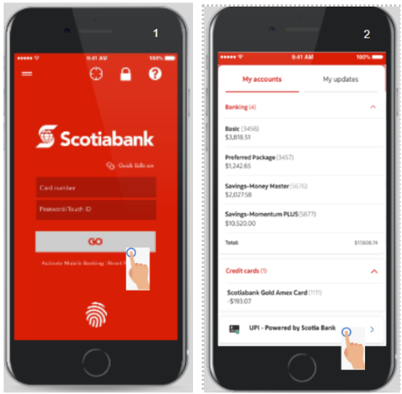

1. UPI homepage appears (It has features like Pay Money, Request Money, Create More VPI and Transactions)
2. Select the option “Create NEW VPI” from the UPI homepage.

* Type a VPI id of your choice in the form [Name/Phonenumber@Scotia.com](mailto:Name/Phonenumber@Scotia.com)
* Check for the availability in case of multiple names registered for VPI.
* Click on “Proceed”

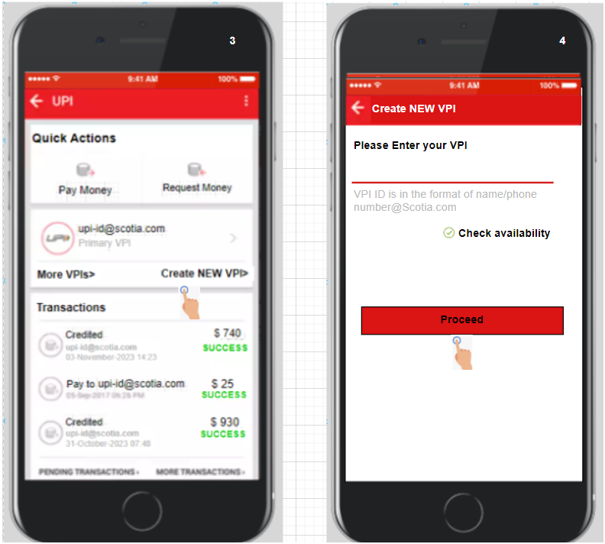

1. For Security purposes, identity verification should be completed before proceeding with VPI creation.

* Select a contact method (Text/Call) to send the verification code.

1. Enter the correct verification code received and then click on proceed.

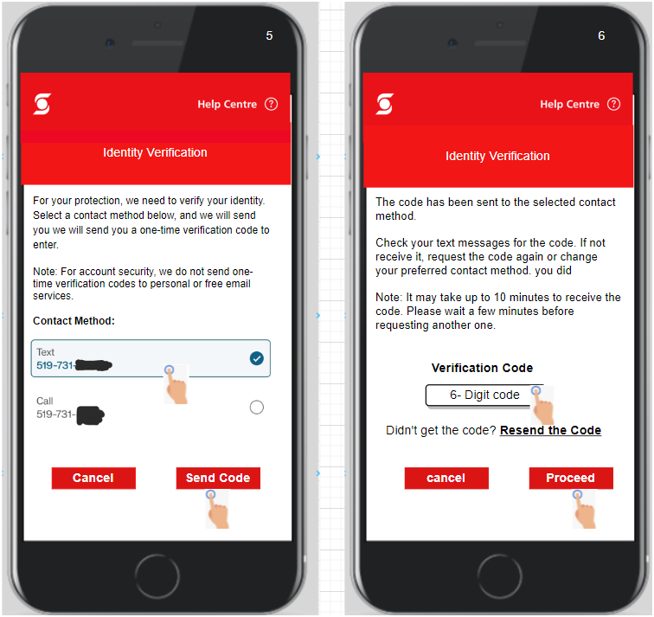

1. If the validation is done, then the screen will show “VPI Created Successfully”.
2. Post successful identity verification, VPA details will be available in the “Security and Settings” option.

* The default checking account, Email, and Phone number will be automatically linked with VPA through the Scotia Bank app.

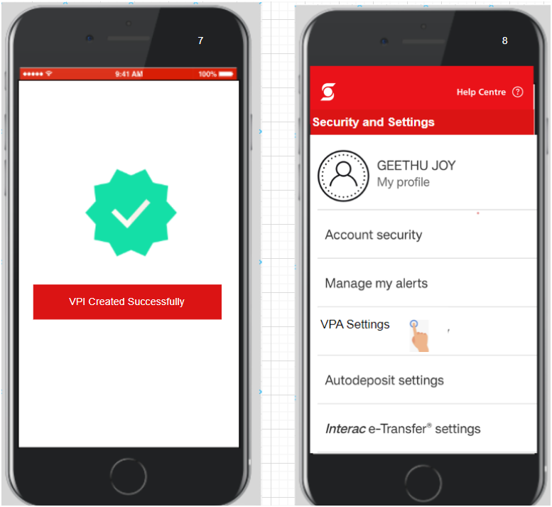

**Pay Money using VPI**

1. First login to Scotia mobile banking app using valid credentials:
2. Click on UPI – Powered by Scotia Bank



1. Select the Option Pay Money as shown in the UPI Home Page
2. Enter the required fields.

* Select or Type a VPI ID To which you need to send money.
* Select the amount.
* Add remarks (Optional)
* Click on Proceed

1. Once the payment is done confirmation message will appear in the screen

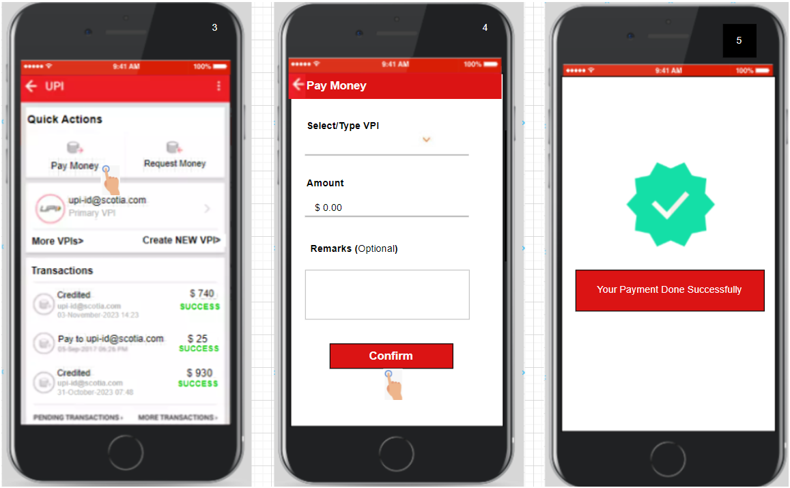

**Requesting money from Scotia UPI platform:**

1. First login to Scotia mobile banking app using valid credentials:
2. Click on UPI – Powered by Scotia Bank
3. UPI homepage appears (It has showcase functionality such as Pay Money, Request Money, Create More VPI and Transactions)

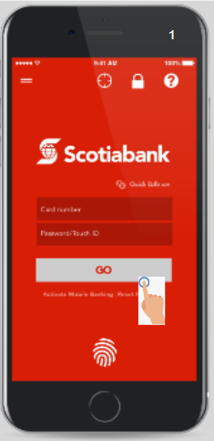 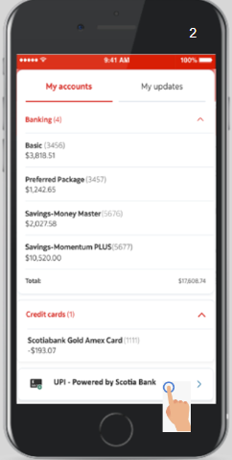 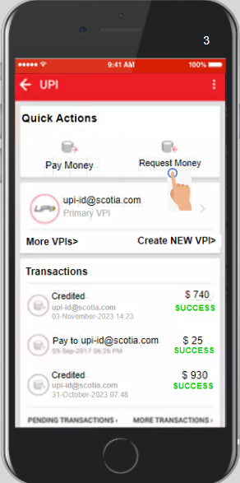

1. For requesting money, Click on “Money Request”.
   * Enter the receiver VPI. The system will automatically check the validation of the entered receiver VPI, else it will ask the user to enter the correct receiver VPI.
   * Enter the amount of the transaction. Here system will check whether the amount is less than the current balance.
   * Enter remarks of the transaction for logging.
   * To proceed with the transaction, click on “Confirm”.

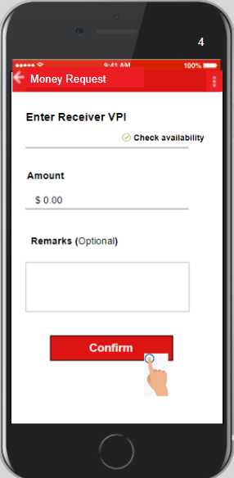

1. You will get an acknowledgement of the request with message “

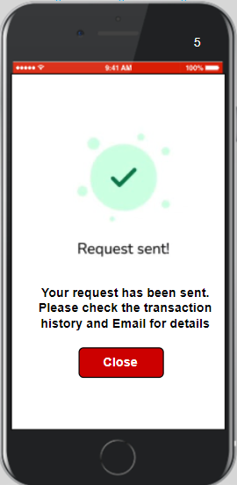

# DATABASE DESIGN

## DATA ELEMENTS & DEFINITION

|  |  |
| --- | --- |
| Users Table | |
| UserID (PK) | VarChar (24) |
| Password | VarChar (64) |
| FirstName | VarChar (50) |
| LastName | VarChar (50) |
| Email | VarChar (320) |
| PhoneNumber | Int |
| Date of Birth | Date |
| Address | Text |
| DateCreated | DateTime |

**Users.UserID**

|  |  |
| --- | --- |
| Field Name: | UserID |
| DataType | VarChar |
| Length: | 24 |
| Purpose: | Unique identifier is permanently assigned to each customer |
| Unit Type: | N/A |
| Range of Possible Values: | Min/Max values |
| Value Explanation: | Values will be alphanumeric |
| Sources: | Mobile banking |
| Security/privacy Constraints: | N/A |

**Users.Password**

|  |  |
| --- | --- |
| Field Name: | Password |
| DataType | VarChar |
| Length: | 64 |
| Purpose: | Highly secured password integrated with MFA used for login |
| Unit Type: | N/A |
| Range of Possible Values: | Min/Max values |
| Value Explanation: | Values will be alphanumeric, special characters. |
| Sources: | User generated |
| Security/privacy Constraints: | Encrypted by SHA-256 hash function |

**Users.FirstName**

|  |  |
| --- | --- |
| Field Name: | FirstName |
| DataType | VarChar |
| Length: | 50 |
| Purpose: | Provides the first name identity of the customer |
| Unit Type: | N/A |
| Range of Possible Values: | Min/Max values |
| Value Explanation: | Values will be alphabet only |
| Sources: | User generated |
| Security/privacy Constraints: | N/A |

**Users.LastName**

|  |  |
| --- | --- |
| Field Name: | LastName |
| DataType | VarChar |
| Length: | 50 |
| Purpose: | Provides the last name identity of the customer |
| Unit Type: | N/A |
| Range of Possible Values: | Min/Max values |
| Value Explanation: | Values will be alphabet only |
| Sources: | User generated |
| Security/privacy Constraints: | N/A |

**Users.PhoneNumber**

|  |  |
| --- | --- |
| Field Name: | PhoneNumber |
| DataType | Int |
| Length: | 10 |
| Purpose: | First-level Contact of the customer. |
| Unit Type: | N/A |
| Range of Possible Values: | 10 |
| Value Explanation: | Values should be number with 10 digits only |
| Sources: | User generated |
| Security/privacy Constraints: | Encrypted as a part of Critical Risk Data (CRD) |

**Users.DOB**

|  |  |
| --- | --- |
| Field Name: | DOB |
| DataType | Date |
| Length: | N/A |
| Purpose: | Date of birth of the customer. |
| Unit Type: | N/A |
| Range of Possible Values: | N/A |
| Value Explanation: | DD/MM/YYYY |
| Sources: | User generated |
| Security/privacy Constraints: | Encrypted as a part of Critical Risk Data (CRD) |

**Users.Address**

|  |  |
| --- | --- |
| Field Name: | Address |
| DataType | Text |
| Length: | N/A |
| Purpose: | Current latest residing address of the customer. |
| Unit Type: | N/A |
| Range of Possible Values: | N/A |
| Value Explanation: | N/A |
| Sources: | User generated |
| Security/privacy Constraints: | Encrypted as a part of Critical Risk Data (CRD) |

**Users.DateCreated**

|  |  |
| --- | --- |
| Field Name: | DateCreated |
| DataType | DateTime |
| Length: | N/A |
| Purpose: | The timestamp at the time the customer was registered |
| Unit Type: | N/A |
| Range of Possible Values: | N/A |
| Value Explanation: | N/A |
| Sources: | System generated by site embedded. |
| Security/privacy Constraints: | N/A |

|  |  |
| --- | --- |
| Accounts Table | |
| AccountID (PK) | VarChar (30) |
| UserID (FK) | VarChar (24) |
| AccountType | Enum |
| AccountNumber | VarChar (50) |
| Balance | Money |
| Currency | Char (10) |
| DateOpened | DateTime |

**Accounts.AccountID**

|  |  |
| --- | --- |
| Field Name: | AccountID |
| DataType | VarChar |
| Length: | 30 |
| Purpose: | Unique identifier is permanently assigned to each customer account |
| Unit Type: | N/A |
| Range of Possible Values: | Min/Max values |
| Value Explanation: | N/A |
| Sources: | Mobile banking |
| Security/privacy Constraints: | N/A |

**Accounts.UserID**

|  |  |
| --- | --- |
| Field Name: | UserID |
| DataType | VarChar |
| Length: | 24 |
| Purpose: | Unique identifier is permanently assigned to each customer |
| Unit Type: | N/A |
| Range of Possible Values: | Min/Max values |
| Value Explanation: | Values will be alphanumeric |
| Sources: | Mobile banking |
| Security/privacy Constraints: | N/A |

**Accounts.AccountType**

|  |  |
| --- | --- |
| Field Name: | AccountType |
| DataType | Enum |
| Length: | N/A |
| Purpose: | Identifies the type of account associated to the customer |
| Unit Type: | N/A |
| Range of Possible Values: | Savings, checking, credit |
| Value Explanation: | Values should be from the range of given value |
| Sources: | Mobile banking |
| Security/privacy Constraints: | N/A |

**Accounts.AccountNumber**

|  |  |
| --- | --- |
| Field Name: | AccountNumber |
| DataType | VarChar |
| Length: | 50 |
| Purpose: | Provides the account number associated to the customer |
| Unit Type: | N/A |
| Range of Possible Values: | Min/Max values |
| Value Explanation: | Values should be from the range of given value |
| Sources: | Mobile banking |
| Security/privacy Constraints: | Encrypted as a part of Critical Risk Data (CRD) |

**Accounts.Balance**

|  |  |
| --- | --- |
| Field Name: | Balance |
| DataType | Money |
| Length: | N/A |
| Purpose: | Money available in the account associated to the customer |
| Unit Type: | N/A |
| Range of Possible Values: | Min/Max values |
| Value Explanation: | Retains and round-off up to two decimal places |
| Sources: | Mobile banking |
| Security/privacy Constraints: | N/A |

**Accounts.Currency**

|  |  |
| --- | --- |
| Field Name: | Currency |
| DataType | Char (10) |
| Length: | N/A |
| Purpose: | Type of currency associated to the customer’s account |
| Unit Type: | N/A |
| Range of Possible Values: | CAD, USD |
| Value Explanation: | Should be either from the range |
| Sources: | System generated |
| Security/privacy Constraints: | N/A |

**Accounts.DateOpened**

|  |  |
| --- | --- |
| Field Name: | DateOpened |
| DataType | DateTime |
| Length: | N/A |
| Purpose: | The timestamp at the time the account was opened |
| Unit Type: | N/A |
| Range of Possible Values: | N/A |
| Value Explanation: | N/A |
| Sources: | System generated by site embedded. |
| Security/privacy Constraints: | N/A |

|  |  |
| --- | --- |
| VPI Table | |
| ReceiverVPIID (PK- Composite key) | VarChar (30) |
| SenderVPIID (PK- Composite key) | VarChar (30) |
| UserID (FK) | VarChar (24) |
| DefaultAccountID (FK) | Varchar (30) |
| VPI | VarChar (30) |
| DateCreated | DateTime |

**VPI.ReceiverVPIID**

|  |  |
| --- | --- |
| Field Name: | ReceiverVPIID |
| DataType | VarChar |
| Length: | 30 |
| Purpose: | Unique number associated to Receiver Virtual Payment Identity |
| Unit Type: | N/A |
| Range of Possible Values: | Min/Max values |
| Value Explanation: | N/A |
| Sources: | Mobile banking |
| Security/privacy Constraints: | N/A |

**VPI.SenderVPIID**

|  |  |
| --- | --- |
| Field Name: | SenderVPIID |
| DataType | VarChar |
| Length: | 30 |
| Purpose: | Unique number associated to Sender Virtual Payment Identity |
| Unit Type: | N/A |
| Range of Possible Values: | Min/Max values |
| Value Explanation: | N/A |
| Sources: | Mobile banking |
| Security/privacy Constraints: | N/A |

**VPI.UserID**

|  |  |
| --- | --- |
| Field Name: | UserID |
| DataType | VarChar |
| Length: | 24 |
| Purpose: | Unique identifier is permanently assigned to each customer |
| Unit Type: | N/A |
| Range of Possible Values: | Min/Max values |
| Value Explanation: | Values will be alphanumeric |
| Sources: | Mobile banking |
| Security/privacy Constraints: | N/A |

**VPI.DefaultAccountID**

|  |  |
| --- | --- |
| Field Name: | DefaulltAccountID |
| DataType | VarChar |
| Length: | 30 |
| Purpose: | The unique identifier is permanently assigned to each customer account |
| Unit Type: | N/A |
| Range of Possible Values: | Min/Max values |
| Value Explanation: | N/A |
| Sources: | Mobile banking |
| Security/privacy Constraints: | N/A |

**VPI.VPI**

|  |  |
| --- | --- |
| Field Name: | VPI |
| DataType | VarChar |
| Length: | 30 |
| Purpose: | A virtual Payment identifier is assigned to each account chosen by the customer |
| Unit Type: | N/A |
| Range of Possible Values: | Min/Max values |
| Value Explanation: | N/A |
| Sources: | Mobile banking |
| Security/privacy Constraints: | N/A |

**VPI.DateCreated**

|  |  |
| --- | --- |
| Field Name: | DateCreated |
| DataType | DateTime |
| Length: | N/A |
| Purpose: | The timestamp at the time the customer was registered |
| Unit Type: | N/A |
| Range of Possible Values: | N/A |
| Value Explanation: | N/A |
| Sources: | System generated |
| Security/privacy Constraints: | N/A |

|  |  |
| --- | --- |
| Transaction Table | |
| TransactionID (PK) | Int |
| SenderVPIID (CK) | VarChar (30) |
| ReceiverVPIID (CK) | VarChar (30) |
| Amount | Money |
| Currency | Char (10) |
| TransactionDate | DateTime |
| Status | Enum |
| Remarks | Text |

**Transaction.TransactionID**

|  |  |
| --- | --- |
| Field Name: | TransactionID |
| DataType | Int |
| Length: | N/A |
| Purpose: | Unique number associated with each transaction |
| Unit Type: | N/A |
| Range of Possible Values: | Min/Max values |
| Value Explanation: | N/A |
| Sources: | Mobile banking |
| Security/privacy Constraints: | N/A |

**Transaction.SenderVPIID**

|  |  |
| --- | --- |
| Field Name: | SenderVPIID |
| DataType | VarChar |
| Length: | 30 |
| Purpose: | Unique number associated to Sender Virtual Payment Identity |
| Unit Type: | N/A |
| Range of Possible Values: | Min/Max values |
| Value Explanation: | N/A |
| Sources: | Mobile banking |
| Security/privacy Constraints: | N/A |

**Transaction.ReceiverVPIID**

|  |  |
| --- | --- |
| Field Name: | ReceiverVPIID |
| DataType | VarChar |
| Length: | 30 |
| Purpose: | Unique number associated to Receiver Virtual Payment Identity |
| Unit Type: | N/A |
| Range of Possible Values: | Min/Max values |
| Value Explanation: | N/A |
| Sources: | Mobile banking |
| Security/privacy Constraints: | N/A |

**Transaction.Amount**

|  |  |
| --- | --- |
| Field Name: | Amount |
| DataType | Money |
| Length: | N/A |
| Purpose: | Amount specified for transaction |
| Unit Type: | N/A |
| Range of Possible Values: | Min/Max values |
| Value Explanation: | Retains and round-off up to two decimal places |
| Sources: | Mobile banking |
| Security/privacy Constraints: | N/A |

**Transaction.Currency**

|  |  |
| --- | --- |
| Field Name: | Currency |
| DataType | Char (10) |
| Length: | N/A |
| Purpose: | Type of currency associated to the customer’s account |
| Unit Type: | N/A |
| Range of Possible Values: | CAD, USD |
| Value Explanation: | Should be either from the range |
| Sources: | System generated |
| Security/privacy Constraints: | N/A |

**Transaction.TransactionDate**

|  |  |
| --- | --- |
| Field Name: | TransactionDate |
| DataType | DateTime |
| Length: | N/A |
| Purpose: | The timestamp at the time the customer performs the transaction |
| Unit Type: | N/A |
| Range of Possible Values: | N/A |
| Value Explanation: | N/A |
| Sources: | System generated |
| Security/privacy Constraints: | N/A |

**Transaction.Status**

|  |  |
| --- | --- |
| Field Name: | Status |
| DataType | Enum |
| Length: | N/A |
| Purpose: | Provides the status of the transaction initiated by the customer |
| Unit Type: | N/A |
| Range of Possible Values: | Pending, Completed, Cancelled, Failed |
| Value Explanation: | Values should be from the range of given value |
| Sources: | System generated |
| Security/privacy Constraints: | N/A |

**Transaction.Remarks**

|  |  |
| --- | --- |
| Field Name: | Remarks |
| DataType | Text |
| Length: | N/A |
| Purpose: | Customers can leave remarks on the transaction to log |
| Unit Type: | N/A |
| Range of Possible Values: | Min/Max values |
| Value Explanation: | Values should be from the range of given value |
| Sources: | User generated |
| Security/privacy Constraints: | N/A |

## SCOTIABANK DATABASE AFTER NORMALIZATION



# RISK LOG

|  |  |  |  |  |  |  |  |  |  |  |
| --- | --- | --- | --- | --- | --- | --- | --- | --- | --- | --- |
| **ID No.** | **Rank** | **Risk Description** | **Category** | **Root Cause** | **Triggers** | **Potential Responses** | **Risk Owner** | **Probability** | **Impact** | **Status** |
| 1 | High | System integration complexity | Technology | Incompatibility between UPI and existing banking systems | Initiation of integration phase | Engage with integration specialists, conduct pilot testing | IT Project Manager | Medium (50%) | High (40) | Open |
| 2 | Medium | Cybersecurity threats increase | Technology | New attack vectors specific to UPI transactions | Launch of UPI services | Implement advanced cybersecurity measures, regular audits | Chief Information Security Officer | Medium (50%) | High (40) | Open |
| 3 | High | Regulatory compliance breaches | Compliance and Regulatory | Lack of clarity in international UPI transaction regulations | Expansion to new markets | Continuous legal review, compliance training programs | Compliance Officer | Low (20%) | High (40) | Open |
| 4 | Medium | Operational disruptions | Operational | Changes in internal processes due to UPI adoption | Implementation of UPI transaction processes | Process reengineering, staff training | Operations Manager | Medium (50%) | Medium (25) | Open |
| 5 | High | Market reluctance to adopt UPI | Strategic | Customer resistance to new technology | Marketing campaign start | Market research, targeted marketing strategies | Chief Marketing Officer | Medium (50%) | High (40) | Open |

# IMPLEMENTATION STRATEGY

**Phased implementation strategy for adding the UPI option in the mobile app**A methodical phase-wise approach to integrating the UPI feature into the Scotiabank mobile application begins with strategic planning, preparation, architecture, and design stages. Detailed design and development include UI creation, back-end integration, and module development. Testing and optimizing input processing, error handling, and performance optimization constitute the final process. The integration stage entails interacting with external agents and sealing a consensus over accurate data. The go-live process comprises deployment and post-launch tasks like training and monitoring users. This approach includes scope out of review, which verifies rejected items, and an impact analysis that considers both positive and negative impacts. A risk mitigation review enables continual and effective management of risks.

* **Phase 1: Planning and preparation** stage, where the project starts with a launching event that forms a dedicated team in charge of specific duties. During this process, a comprehensive requirement analysis is conducted to identify possible risks and develop an effective risk mitigation strategy. Setting up infrastructure and resources includes configuring development and test environments and having available tools tested for proper functionality.
* **Phase 2:** We will concentrate on the **high-level architecture** concerned with formulating the high-level design, client-server model, UI module, error handling, and backend integration. Initial client-server integration begins to establish a secure connection as the development of modules commences at the beginning of coding procedures. In this, scalability issues and a question of the architecture’s ability to grow along with the number of users should also be addressed.
* **Phase 3:** In detailed **design and development**, the creation of user-friendly interfaces precedes integrated backend links connecting the Mobile app to Scotia back-end systems. In module development, there will be implementations and tests of handling the UPI transaction with errors, among other essential aspects. Attention to data flow guarantees smooth communication of information between the mobile application, outside services, and systems implemented by the bank.
* **Phase 4: Testing & Optimisation**: User Input Validation, Error Handling Implementation & Performance Optimisation. Backend integration also secures communication while user interface design is finalized. Validation algorithms and error handling are thoroughly tested, and performance optimizations are designed to improve the system’s performance.
* **Phase 5:** Finally, there is integration for API purposes **and finalization.** The mobile app integrates data synchronization mechanisms to maintain up-to-date transaction data between it and other external systems. It includes the process of smooth information interoperability with outside organizations.
* **Phase 6: Deployment and post-deployment** considerations comprise making an elaborate plan for the non-glitch operation of all UPI mechanisms. User training will also be essential to prepare both the users and the customer support to understand and appreciate the new features. The Go-live process occurs with scrutiny; then, post-launch follow-ups such as continuous monitoring, collecting feedback, and implementing improvements based on the conclusions obtained.
* **Impact Analysis Review:** At this level, one assesses the costs and benefits of implementing UPI. Included are the effects on customers’ satisfaction, advantages in dealing with competitors, ease of operations, compliance with regulations, ability to retain customers, creation of extra revenues, and transaction simplicity. However, we will review to see how we could improve the good elements and tackle the negative ones.
* **Risk and Mitigations Review:** This is meant to reassess and update the risk mitigation plan. It entails reassessing the identified risk, seeing that the mitigation strategy is appropriate, and examining newly developed risks. Management constantly monitors the efficacy of a planned process with constant risk reviews.

# TESTING STRATEGY

## Solution #1 - (**ADDING THE UPI OPTION IN THE EXISTING SCOTIA BANK MOBILE APP)**

**Scope:**

The document will be reviewed by the project team, including developers, testers, and project managers. Additionally, stakeholders from Scotia Bank may also review the document to ensure alignment with business requirements. The document will be approved by the project manager in collaboration with key stakeholders from Scotia Bank.

Software Testing activities carried out with timelines:

Testing activities will be conducted throughout the development lifecycle:

* Unit testing: It includes verifying UPI fund transfer functionality, validate user interactions in the dedicated UPI section, and ensuring error handling provides clear and informative messages. These tests will be carried out concurrently with development.
* Integration testing: After the completion of unit testing, within 1-2 weeks.
* System testing: After integration testing, within 2-3 weeks.
* User acceptance testing (UAT): Prior to release, within 2-3 weeks.

**Test Approach:**

* Process of testing: Testing will follow a phased approach, starting from unit testing and progressing to system testing and UAT.
* Testing levels: Unit Testing, Integration Testing, System Testing, User Acceptance Testing (UAT)
* Roles and responsibilities of each team member:
* Developers: Responsible for unit testing Address defects and assist in troubleshooting.
* Testers: Conduct integration, system, and UAT testing Log defects.
* Project Manager: Overall coordination and monitoring.
* Business Analysts: Validate business requirements.
* Types of Testing:
* Functional testing - Verify that the UPI fund transfer feature in the Scotia Bank mobile app performs as expected, correctly initiates transfers, validates recipient details, and confirms payments.
* Performance testing (non-functional testing) - validate the scalability of the new feature to ensure the Scotia Bank mobile app can manage a growing number of UPI transactions, providing users with a smooth and responsive experience during fund transfers without any issues.
* Security testing (Non-functional testing)- Validate the robustness of security features in place, including encryption and authentication, to safeguard user data and prevent unauthorized access during UPI transactions in the Scotia Bank mobile app.
* Integration testing - Ensure smooth interaction between the Scotia Bank mobile app and external UPI service providers, as well as the bank's backend systems, to makes sure a secure and reliable connection for UPI fund transfers.
* User Acceptance Testing (UAT): Involve actual users in testing the UPI fund transfer feature, obtaining feedback on the user interface, transaction flows, and overall user experience to ensure it meets user expectations and preferences.
* Regression Testing: Confirm that existing functionalities within the Scotia Bank mobile app are not negatively impacted by the integration of the UPI fund transfer feature, ensuring a stable and consistent user experience across all features.
* Testing approach & and automation tool if applicable:
* Manual testing for unit, integration, and system testing.
* Automation tool (e.g., Selenium) for repetitive and regression testing.
* Adding new defects, re-testing, Defect triage, Regression Testing, and test sign-off:
* New defects are logged promptly with detailed information.
* Re-testing will be conducted after defect resolution.
* Conduct defect triage meetings to prioritize and assign defects.
* Regression testing after each code change.
* Test sign-off will be done after successful completion of UAT.

**Test Environment:**

There are four environments required, development Environment, Testing Environment, UAT Environment, and Production Environment. Also Test in different mobile devices (iOS and Android) and network conditions, to ensure the UPI feature is robust across different scenarios. Regular backup of data is recommended and there should be a restore strategy in place in case of data corruption or loss.

**Testing Tools:**

Automation Tool Selenium can be used for UI testing. Jira can be used for test case management. License and other requirements need to be defined based on team size and testing needs.

**Release Control:**

A detailed release management plan outlining version history will be created for each change. Major versions for significant changes, minor versions for feature additions, and patch versions for bug fixes.

**Risk Analysis:**

Identified risks:

* Technical Issues and Outages
* Security Breaches.
* User Error
* Compliance Challenges
* Third-party Dependencies

Mitigation plan:

* Conduct regular extensive testing, including penetration testing and load testing, to identify and address technical vulnerabilities.
* Update security procedures regularly to stay ahead of evolving threats. Implement robust security mechanisms.
* User-friendly interfaces with clear instructions.
* Solid vendor relationships with backup plans

**Review and Approvals:**

* Conduct regular review meetings with stakeholders and Sign-off by business, project management, and development teams.
* A summary of review changes should be traced at the beginning of the document along with an approved date, name, and comment.

Note: This test strategy plan is a high-level document. Detailed test plans and test cases will be created during the testing process.

# REFERENCES

1. Bichachi, R. (2023, March 29). *Payment Reconciliation Defined: How It Works & How to Automate*. Oracle NetSuite. <https://www.netsuite.com/portal/resource/articles/accounting/payment-reconciliation.shtml>
2. Jacob, H. S. M. E. (2021). *Unified Payment Interface (UPI)—A Critical Review of Benefits and Challenges of Advanced Payment Systems*. <https://www.webology.org/abstract.php?id=2638>
3. Ganti, A. (2023, June 21). *Unified Payments Interface (UPI): Definition and How It Works*. Investopedia. <https://www.investopedia.com/terms/u/unified-payment-interface-upi.asp>
4. Hamilton.T, (Oct 14,2023), Test Strategy Document in Software Testing (Sample Template), Retrieved from [Test Strategy Document in Software Testing (Sample Template) (guru99.com)](https://www.guru99.com/how-to-create-test-strategy-document.html)
5. Pollack, E. (2022, April 24). *Building a SQL Server data dictionary*. Simple Talk. <https://www.red-gate.com/simple-talk/databases/sql-server/database-administration-sql-server/building-a-sql-server-data-dictionary/>
6. Scotiabank (BNS) - Market capitalization. (2023). Companiesmarketcap.com. <https://companiesmarketcap.com/scotiabank/marketcap/>
7. Sharma.G, (n.d), Test and Debug: Ensuring a Seamless UPI Application, Retrieved from <https://devpathshala.com/test-and-debug-ensuring-a-seamless/>
8. Staff, P. (2023, August 8). Scotiabank vs RBC: Comparison of Canadian Banks - PiggyBank. PiggyBank. <https://piggybank.ca/banking/scotiabank-vs-rbc>
9. *Unified Payments Interface*. (2023, September 14). Wikipedia. <https://en.wikipedia.org/wiki/Unified_Payments_Interface>